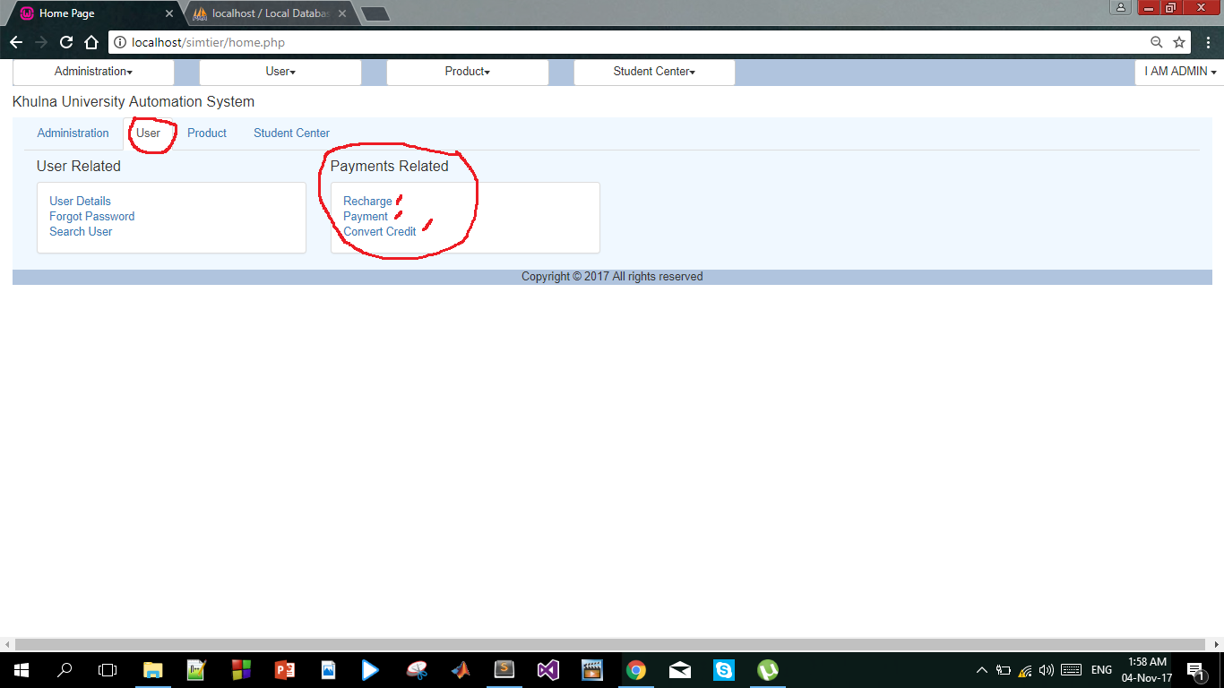

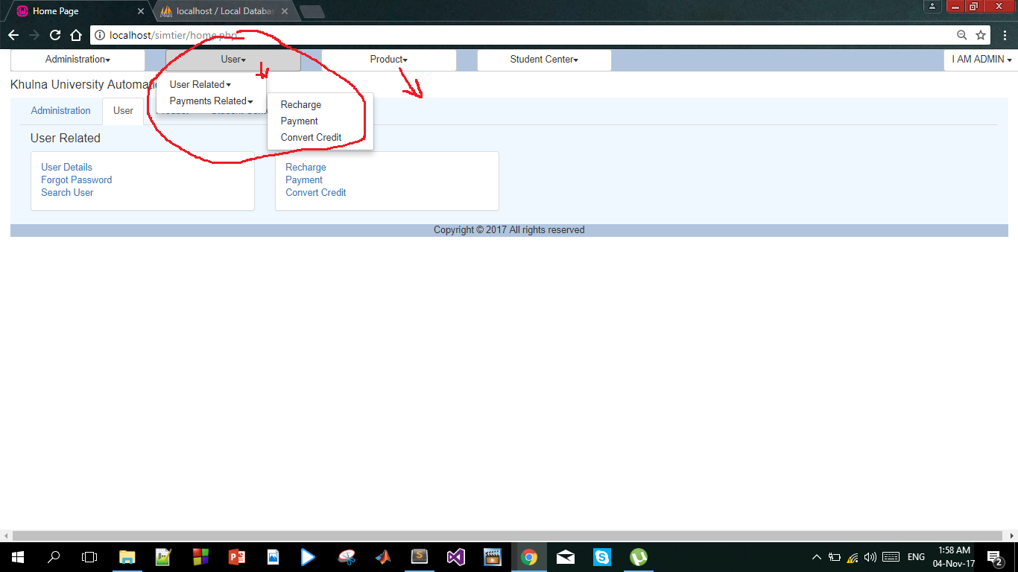

***Payment Related:***

* ***Recharge***
* ***Payment***
* ***Conversion of credit***

***--------------------------------------------------------------------------------------------------------------------***

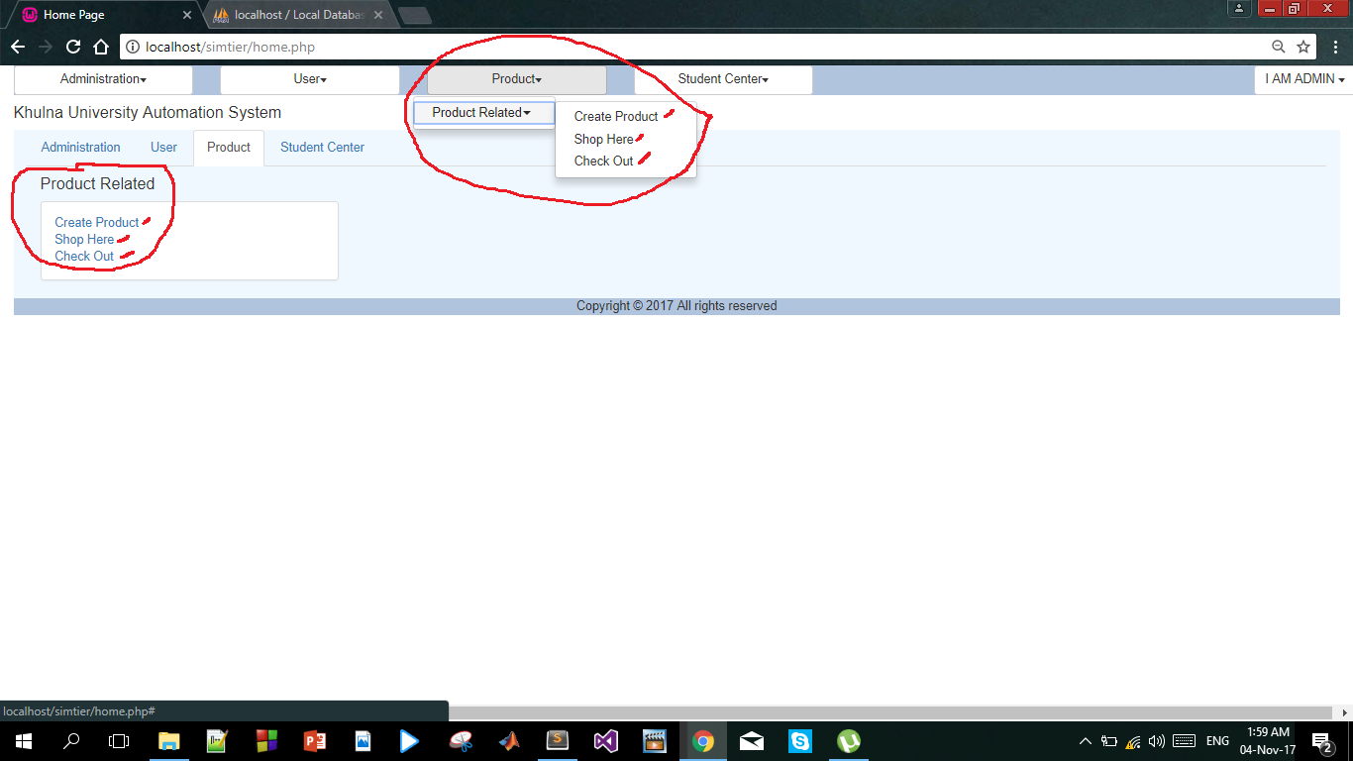

***Product Related:***

* ***New Product Creation***
* ***Shopping Place***
* ***Check Out***

***----------------------------------------------------------------------------------------------------------------------***

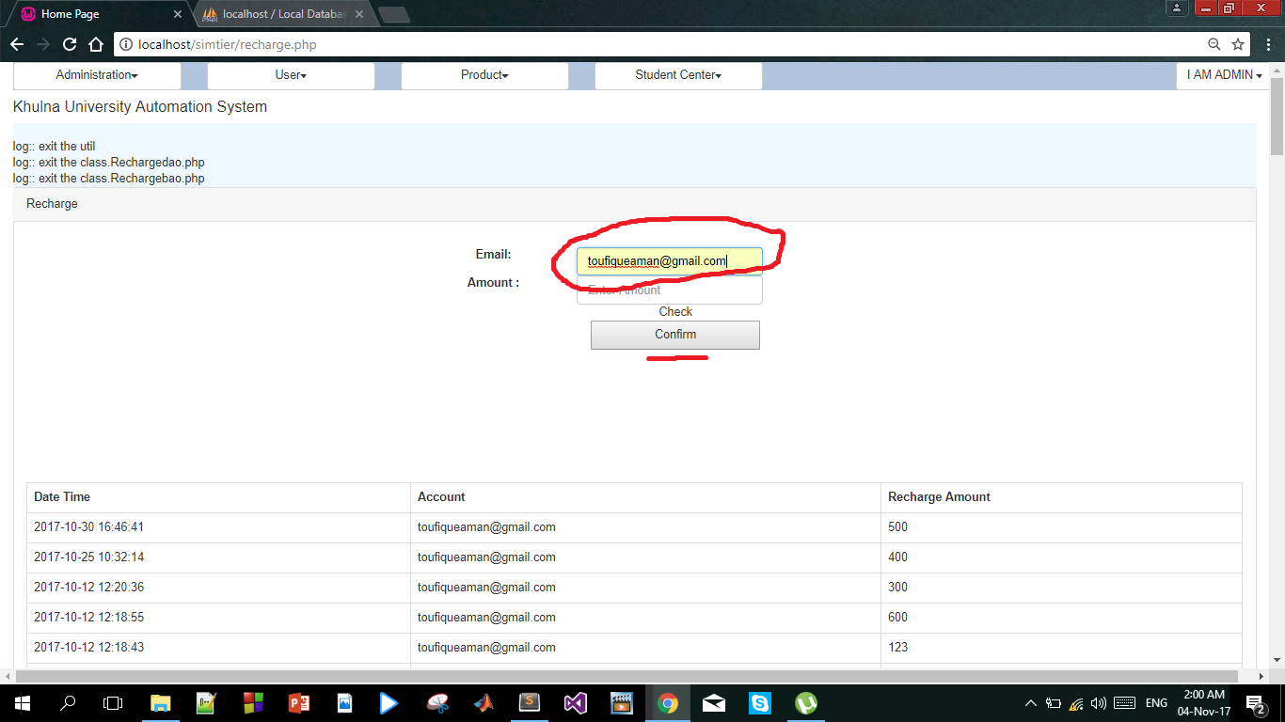

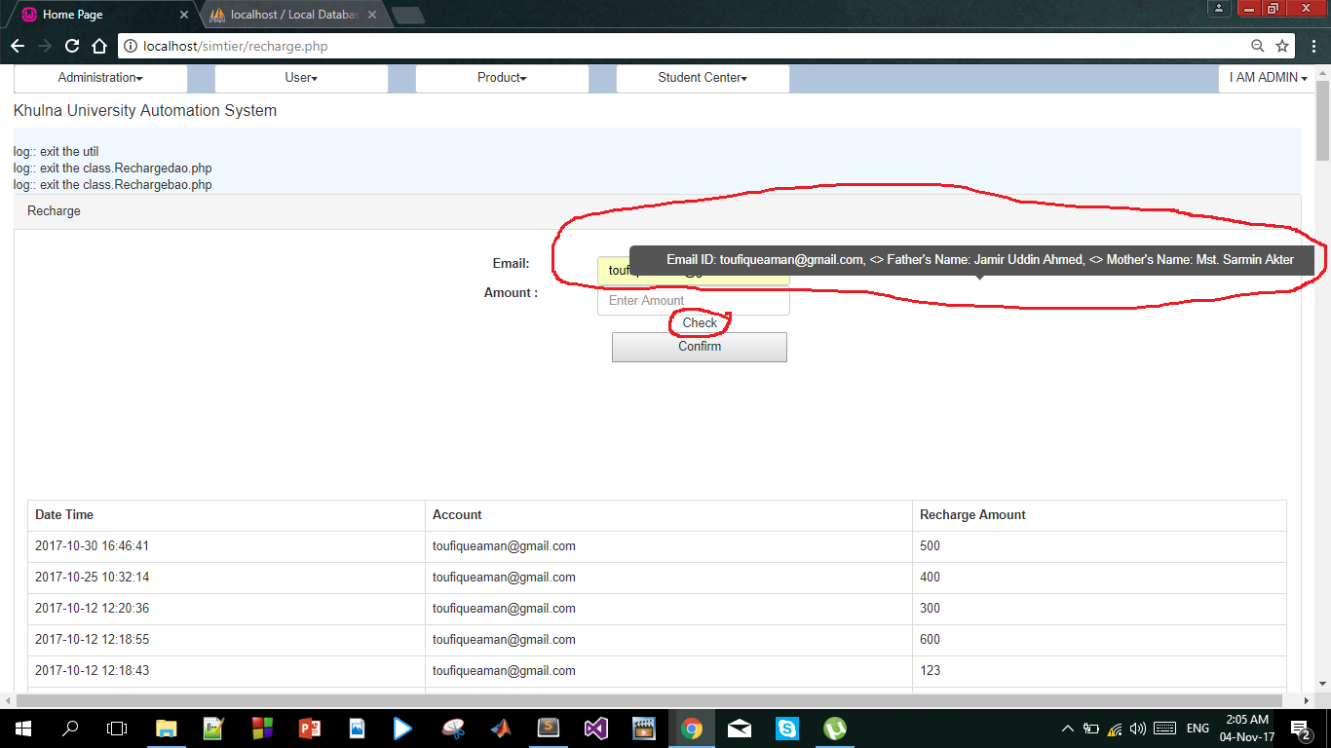

* ***By Entering an email and Clicking on “check” we’ll get some information about the user.***

***----------------------------------------------------------------------------------------------------------------------***

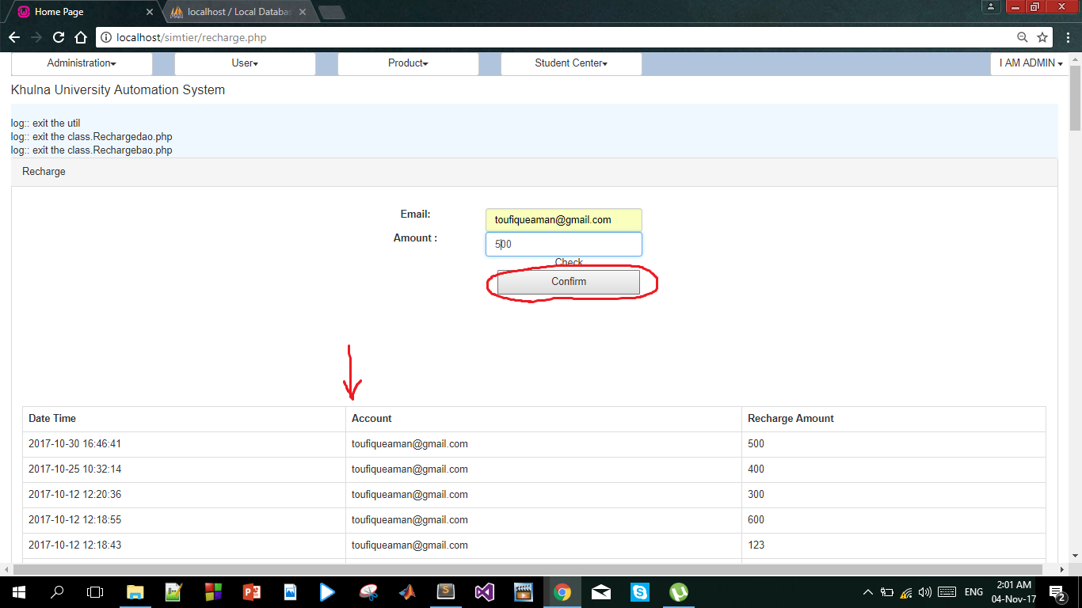

* ***By clicking on “Confirm” admin makes the confirmation about the recharge and showing on the log.***

***-----------------------------------------------------------------------------------------------------------------------***

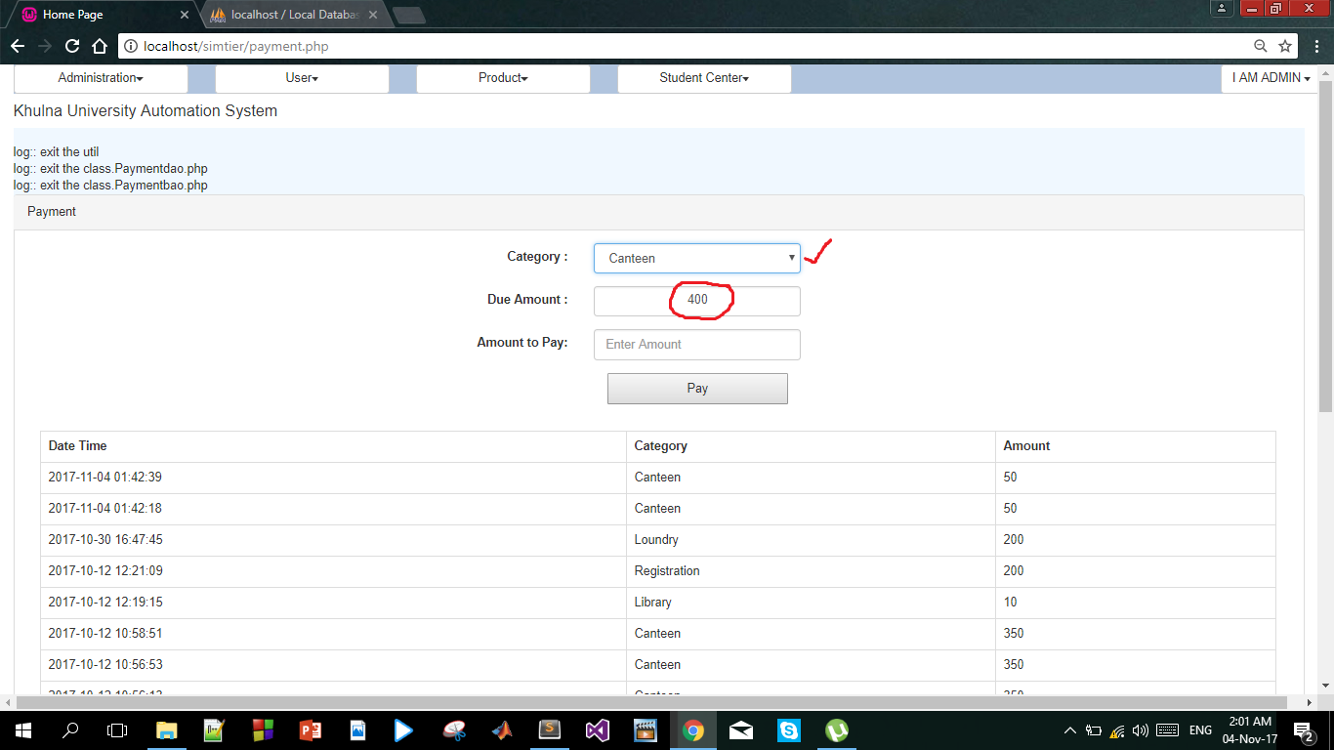

* ***On the “Payment” page we can get category wise due amount if the user has any due***
* ***User can pay amount by clicking “Pay”***
* ***Paid amount will be deducted from his/her balance.***
* ***This page shows payment log for that particular user.***

***------------------------------------------------------------------------------------------------------------------------***

* 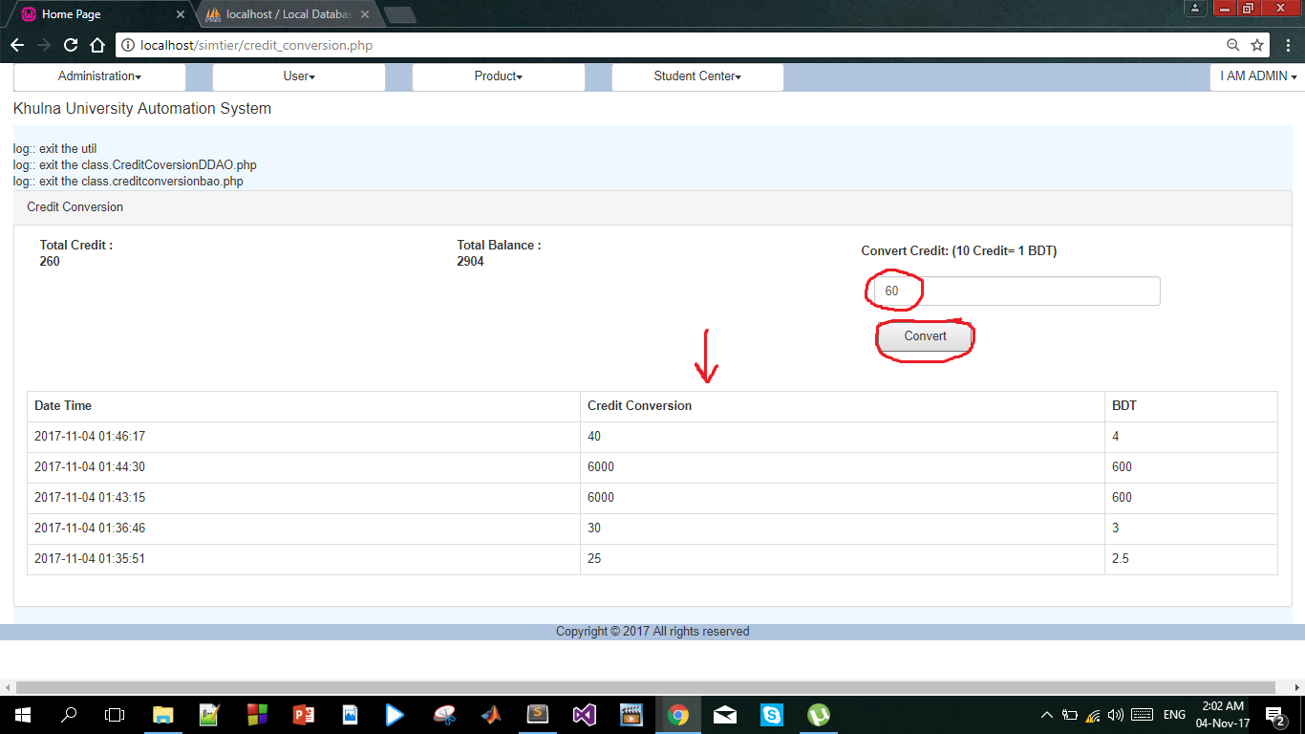
* ***In “Credit Conversion ” page we can convert user earned credit to balance***
* ***Credit comes from purchasing some price.***
* ***This page shows the credit conversion log for that particular user.***

***------------------------------------------------------------------------------------------------------------------------***

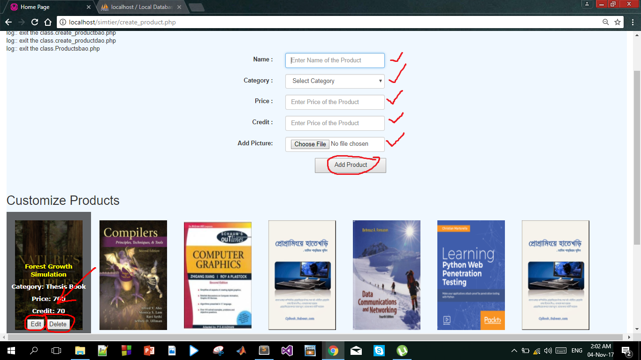

* ***This is product creation page where admin who has the access to add product can add or customize***

***product.***

***-------------------------------------------------------------------------------------------------------------------------***

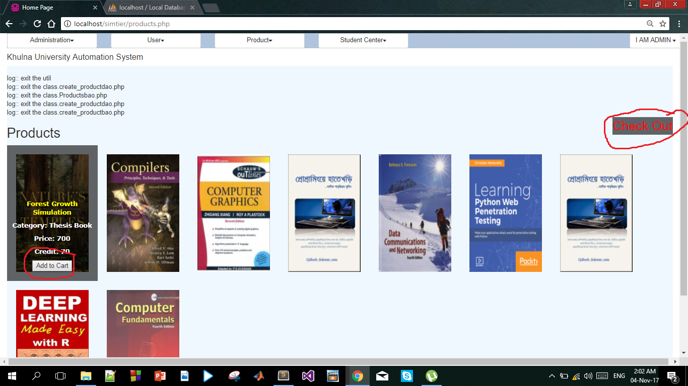

* ***This is “Shopping” page where any user can add some product to his cart by clicking “Add to Cart” button.***
* ***Here the product details along with price and credit which are fixed by the admin is shown.***
* ***After adding into the cart user can check out by clicking on the link “Check Out” instantly or s/he can***

***check out later directly from the menu.***

***--------------------------------------------------------------------------------------------------------------------------***

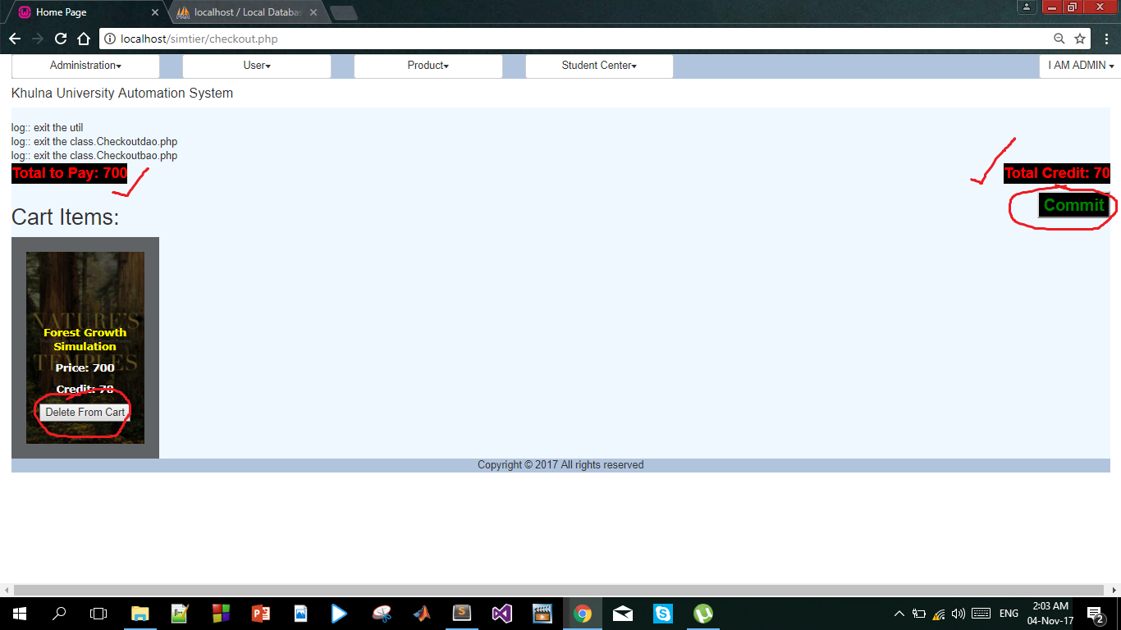

* ***This is Check Out page where user can checkout items which were added to the cart.***
* ***User can also delete items from the cart.***
* ***Total amount to be paid and total credit to be earned is shown on top.***
* ***The paid amount is deducted from the balance and earned credit is added to the amount of existing credit.***